Bio and Selected Media Placements and Reviews

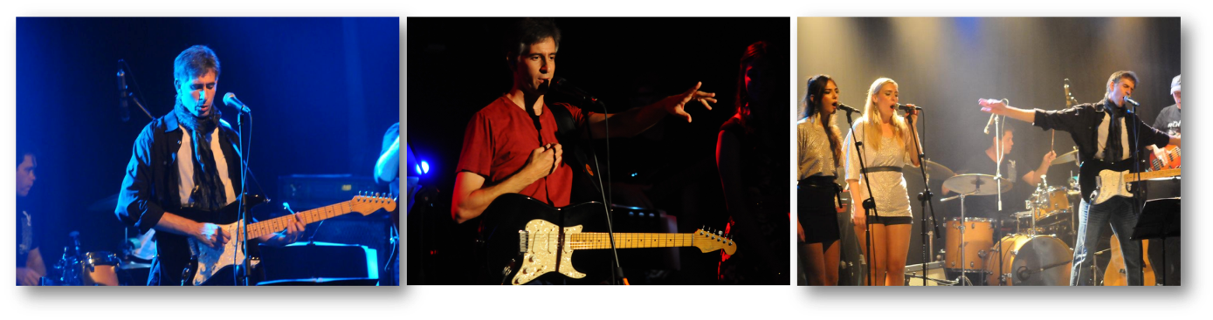
Contact: makeclassicsrock@gmail.com
972-54-4414594
Official Website
http://www.giladsmusic.com/
Gilad is an Israeli Indie singer and songwriter releasing his 3rd album, As Time Goes By. Gilad has created his own musical genre combining his two loves; 70's rock and a passion for classical poetry. His previous album Hidden Flame, combined Gilad's unique music style with poems by, Christina Rossetti, Edgar Allen Poe, Hemmingway, Kipling, John Dryden among others. He started out as a cover band in the '90s and later added his own material to the setlist.
Gilad has since gone on to perform on prime-time TV, received national radio exposure, wrote 3 musicals, and to top it off received a personal thank you letter for his work from US President Barack Obama.
His music is quoted as being a beautiful mix of Pop, Rock, Light Soul, and a bit of Jazz.
His second release from his new album is In My Hometown. A song about growing up in the 80s'. spending most of the time outside with his friends.
The previous one was Avigail's Song. Bothe are available on Spotify and all other digital platforms.

Semi-Finalist placement in the Song of the Year contest 2021

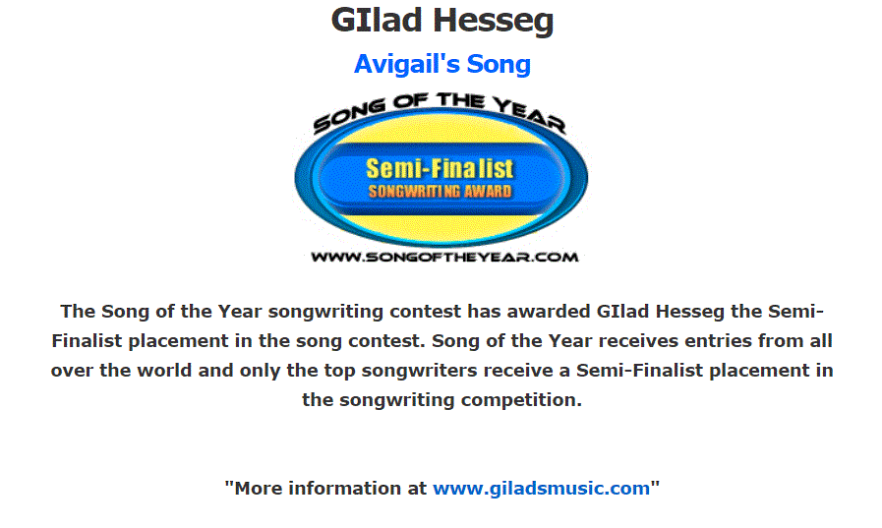

Sara Alice - The Soundcheck
Journalist, Media·Italy
I have to say this piece is beautiful. I particularly love the voice which reminds me so much of British singers like Phil Collins.

The Sounds Won't Stop
Journalist·United States
This was great! We'll get this shared on our Instagram page as soon as we can! Thanks so much!
UK Independent
Radio·United Kingdom
Love how this record starts, a great piece of pop here that I can't get enough of. A unique voice as well.

Personal Letter from President Barack Obama
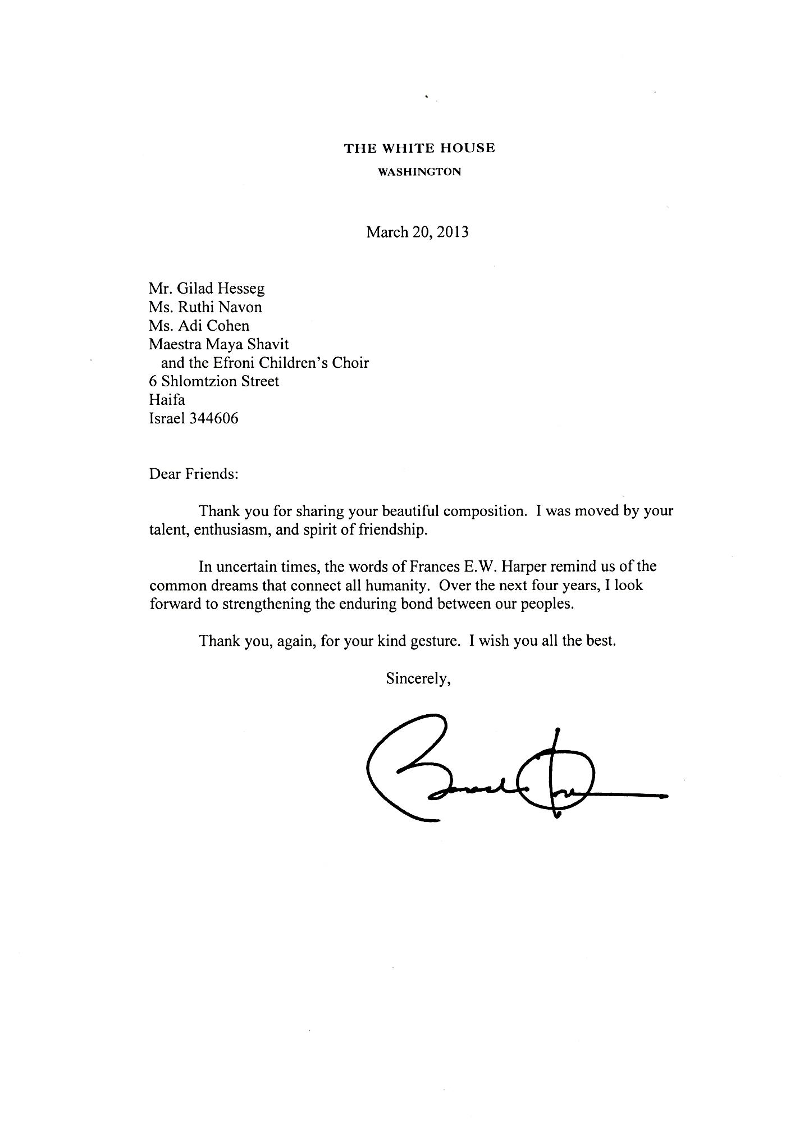
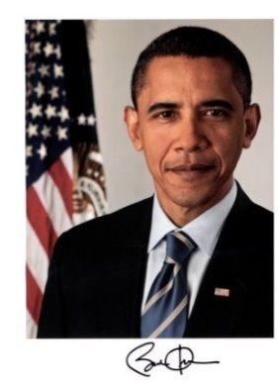

XUNEMAG (Internet Portal)
https://xunemag.com/gilad-annabel-lee-review/
One thing I can’t help but praise this track for is it’s captivating lead guitar solo and various lead guitar parts throughout. The vocals on the track give off a classic sound, especially when the background vocals appear. ‘Annabel Lee’ boasts plenty of depth and layers and fully feels like a journey from start to finish

16TH ANNUAL GREAT AMERICAN SONG CONTEST
My Song Annabel Lee was selected as a finalist in 2013.

The Marker Café (Internet Portal, 3-5 hundred thousand views a day):
http://cafe.themarker.com/review/2792255/
I thought nothing could surprise me anymore but I'm happy to say I was wrong, big time. I love a good surprise and Gilad's concert was absolutely amazing. A new concept executed to perfection, great music, what can I say – Perfect!
Rudyard Kipling combined with light Rock and Roll, who would have believed it?
The music is melodic and catchy, with brilliant arrangements.
Yoval Harel's Blog (500-800 views a day):
http://yuvalerel.wordpress.com/2012/12/06/%d7%94%d7%90%d7%a9-%d7%94%d7%a0%d7%a1%d7%aa%d7%a8%d7%aa-%d7%a9%d7%9c-%d7%92%d7%99%d7%9c%d7%a2%d7%93/#more-10688
There is something magical and undefined about listening to Gilad singing contemporary Rock music using lyrics of Classical Poetry. It's as if two worlds combined together.
Richard Coffee/Artistic Dir./Connecticut Choral Artists, Inc.
http://www.giladsmusic.com/reviews.html
Dynamic, fresh, and engaging, marked by a youthful vigor and passion that are hallmarks of the poems themselves.
Stanley Sperber/Dir. of Choral Music/Jerusalem Academy of Music and Dance
http://www.giladsmusic.com/reviews.html
Highly dramatic and poignant compositions… an artistic triumph!
Reuven Bardah's Blog (500-200 views a day):
http://www.mynet.co.il/articles/0,7340,L-4329018,00.html
Gilad knows that in order to write and sing in English you need to be - English and that’s why he chose some of the best known texts in the English language by poets such as: Hemingway, Poe, Kipling and others.
Gilad's voice reminds me of Adam Levine from Maroon 5. His music is a beautiful mix of Pop, Rock, Light Soul, a bit of Jazz and Celtic music.

The Times Of Israel (Internet Portal, 3-5 hundred thousand views a day, around the world):
http://www.timesofisrael.com/topic/gilad-hesseg/
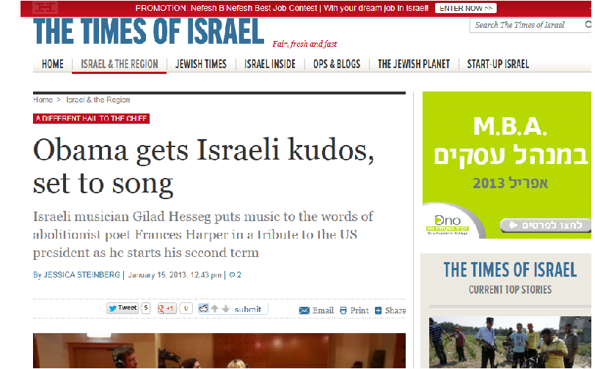

Israel Today (The circulation is currently 350,000 a day for the daily edition):
Israeli composer recorded a Tribute Song to the lyrics of poet Frances E. W. Harper, in honor of President Obama's inauguration ceremony.
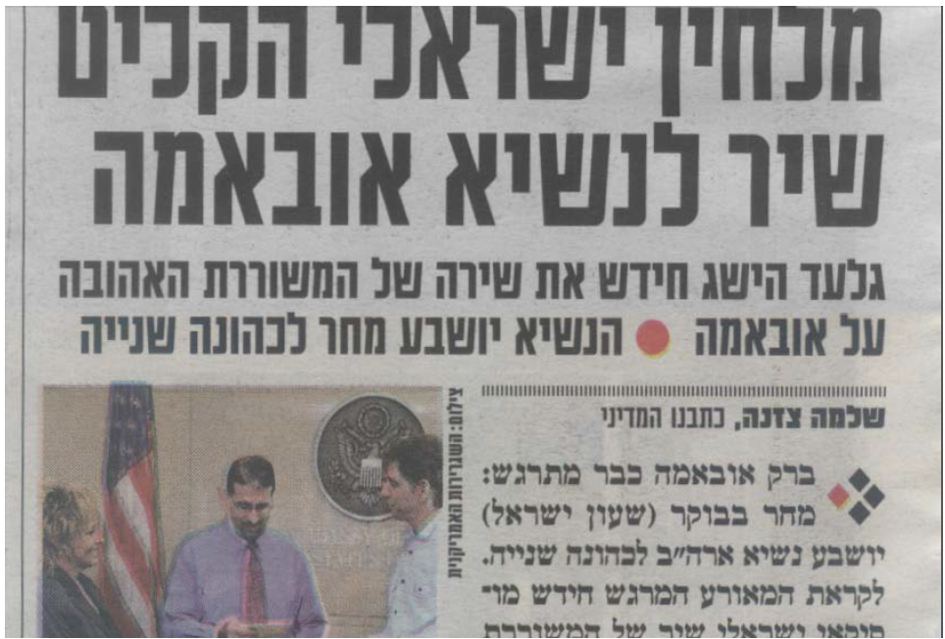
Israeli Foreign Ministry – video interview :
http://www.facebook.com/giladsmusic#!/CultureBuzzIsrael?fref=ts
Jerusalem Post – Back page (daily circulation of tens of thousands and also a very wide circle of readers all over the world):
http://www.jpost.com/ArtsAndCulture/Music/Article.aspx?id=242885
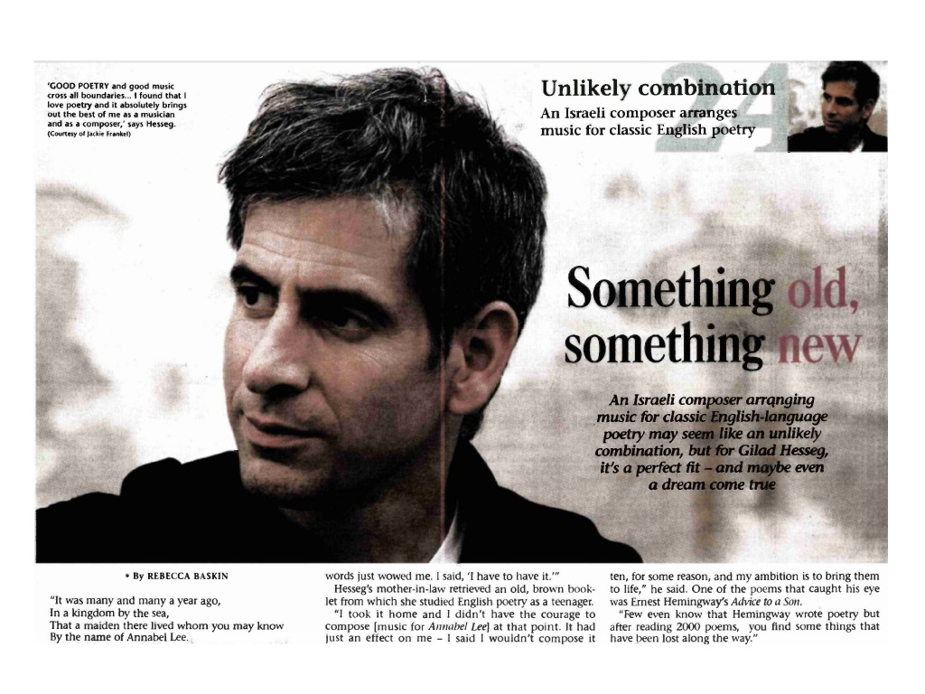
Walla (Internet Portal – 600,000 views a day):
http://e.walla.co.il/?w=/202/2561840
Mako (Internet Portal – 300,000 views a day):
http://www.mako.co.il/music-news/singles/Article-4c31814b96c5c31006.htm
Habama (Internet Portal – 150,000 views a day):
A Powerful and gentle sound
http://www.habama.co.il/Pages/Description.aspx?Subj=7&Area=1&ArticleId=10514
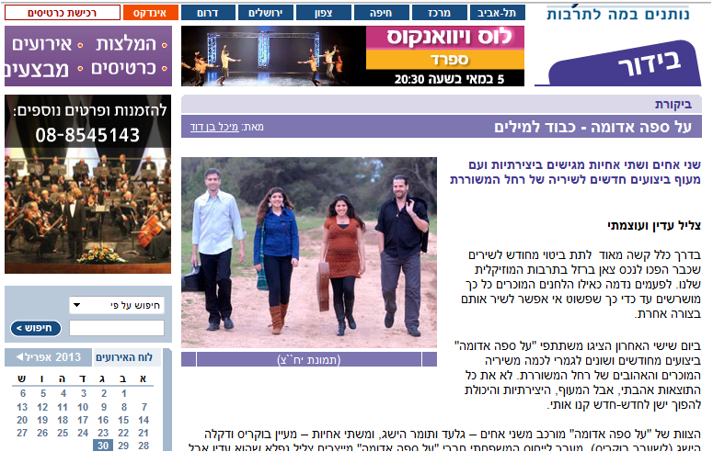

YouTube
"That was absolutely ﻿incredible!!﻿ Thank you"
YouTube
Our class looked at this video and it﻿ was truly mastered. You sang it perfectly.
YouTube
"Savrseno, perfect !!!"

